Somewhere over the High Seas there is a Land of My Dreams – Happiness and Life Satisfaction among Immigrants in Europe

Olli Kangas
September 2012

Introduction

The history of Homo Sapiens is a history of constant movement. If we are creationists and believe in the Bible, the first emigrants forced out of their home were Adam and Eve. Those two ancestors of ours, expelled from their garden as such, were the start of the future trajectories for humankind that – according to evolutionists – has moved from Olduvai Gorge to the highest peak of Terra del Fuego to the banks of the Bering Strait. Sometimes moves are motivated by the search for a better life or a sheer desire for adventure and excitement, sometimes moves are forced by violent armies or extreme poverty, hunger, disease and threat of premature death. Worldwide, there are by now about 220 million people living outside their own country. Out of those movers, some 50 million reside within the boundaries of the European Union (EU), of which 30 million come from outside the EU and 20 million have their country of origin in some other EU member state.

A common procedure in welfare research is to trace differences between welfare states and welfare regimes. Following Esping-Andersen’s seminal work, social scientists have clustered countries according to social policy institutions. Initially, three separate models of welfare capitalism existed: the Social Democratic (Nordic/Scandinavian), the Liberal (Anglo-Saxon) and the Conservative (Continental/Central-European). Later, two other models were added to the list: the South-European and Post-Socialist.

Welfare state models are a handy tool for social scientists to use to explain almost all social phenomena when applied to regimes in different domains: e.g. the incidence of poverty and social exclusion, employment and unemployment, gender equality and woman-friendliness, dominance and privilege, birth and death, health and sickness, opinions and attitudes etc. The aim of this study is to expand the field of application and take a look at happiness and life-satisfaction among those 50 million or so immigrants that have their new homes in Europe.

The views of happiness and its importance to social research vary. Some critical analysts argue that happiness is an individually generated state of mind, i.e. a subjective feeling and hence not a real thing. As such, it is not a proper object for scientific inquiry. However, psychologists, armed with fancy brain probing devices, have discovered that happiness is a specific kind of electric activity in the frontal part of the brain. Thus, happiness obviously is a real and scientifically measurable thing. From the social science point of view, the key question to ask pertains to the kind of phenomena that cause those positive electric waves in the brain. As there are plenty of reasons to explain happiness and misery, it is little wonder that a growing plethora of competing explanations exist pertaining to the preconditions for a happy life.

There are also a growing number of studies on immigrants and their happiness. For example, the Social Indicators Research journal launched a special issue on immigrants and their subjective well-being in Europe.. From our point of view, the intriguing question deals with the extent, if any, that the level of life-satisfaction and happiness of immigrants varies between the five welfare state regimes. We are interested to discover whether there are systematic differences between the welfare states and welfare regimes and how immigrants coming from different regimes evaluate their happiness in their new surroundings. What is the role of the prosperity of the country of residence? How important are other contextual factors such as income distribution and the level of social protection? What about gender differences between regimes? Given the discussion of the woman-friendly welfare state, we could expect that the Nordic countries, in particular, should contribute towards life-satisfaction among female migrants. How strongly do the individual characteristics of immigrants – age, gender, health, income, employment status and social networks affect their life-satisfaction? We are also interested to know whether relationships between explanatory variables and happiness vary between welfare state regimes.

The structure of the chapter is as follows. The next section depicts a broader theoretical frame of reference that this study is linked to. Thereafter, a section on previous studies in the field is presented, which also specifies more detailed research tasks. This is then followed by a section dealing with the data and methods used. The section ‘Happy immigrants live in happy countries’ presents the main analyses and empirical findings, and the final section discusses the results obtained.

General starting points: individualistic and collectivist approach to happiness

Happiness has made a phenomenal entry into the high chambers of scientific inquiry. Soft social scientists are not the only ones to be thrilled about studying happiness today; hard-core economists and strict scientists are too. Needless to say, the search for happiness takes place in different domains and by different methods depending on the discipline of the scholar.

While a psychologist would search for signs of happiness in the dorsolateral prefrontal cortex of the brain, using electroencephalogram and positron emission tomography, a social scientist would apply surveys and ask people how happy they feel. Although the approaches may seem very distant from each other, it has been shown that there is also a close correspondence between electrical activities in the left front of the brain – indicating happiness – and people’s own opinion of their state of mind. Whereas the psychologist tries to trace electrical waves, the issue for the social scientist is to discover the societal contexts and conditions that actually cause that positive electrical brain activity in the first place.

The possible link between an individual’s physiological status, social position and the characteristics of the society he/she lives in has been widely discussed by epidemiologists, and the conclusion has been that social factors – income, employment, our position in social hierarchy, social relations, etc. – are of importance for our health. Whereas an advantageous position in society has a multiplier effect leading to better education, better income and health, as well as to a longer and happier life, in a disadvantageous position harmful things tend to accumulate: low educational attainment, low income, health problems, lower experienced happiness, and life expectancy that is years behind that of people in better positions in society.

Within social sciences and between political camps there are substantial differences in the interpretations of the social prerequisites of misery and happiness. With some simplification, we can distinguish two main sets of explanations – and the huge grey area between them – that have bearing for this study. First, in the individualistic perspective, happiness is deeply regarded as an individual phenomenon that is achieved by individuals themselves. As such, individual freedom is set into focus, which also dictates the subsequent role of the national state and sets limits for state actions. In this approach, rooting back into the ideas of classical liberalists, the state is seen to exercise its jurisdiction through coercion that is offensive to people's autonomy. For example, the government levies taxes, which cuts into people's personal resources and limits their personal freedom and thus their possibilities to choose. Liberty begins where the state ends; liberty is only realisable in the private sphere, not in the area of public policy. In order to maximise liberty, and hence to trigger individual happiness, the activities and tasks of the state should be limited. For example, when it comes to economic growth and prosperity, often regarded as the best determinants for a happy life, the most important issue is to create growth and a high gross domestic product (GDP), whereas the distribution of prosperity is secondary. People are happy if they live in a rich country regardless of the inequality concerning how the wealth in the country is distributed. This kind of political attitude is supposed to underpin right-wing welfare thinking, and in particular the social policy making in the United States.

The second view is more collectivistic. In collectivist thinking, the interpretation of human beings, their happiness and other conditions of living are defined contextually, always in relation to the prevailing standards in the society where they live. In contrast to the individualist approach, the collectivist tradition also pays attention to distributional issues: not only is the level of prosperity important, even more important than the level of prosperity is how evenly prosperity is distributed. Equality is better for everyone, argue Wilkinson and Pickett in their influential The Spirit level.

The overarching theme of the collectivist tradition deals with the resources and possibilities society offers to its members. This idea has been an explicit starting point in the Nordic welfare state studies and the very same idea is making a new entry in the clothing of the new social investment welfare state. The main idea has been to measure welfare with the help of the resources individuals have at their disposal. For example, in the Swedish level of living surveys, well-being was measured on nine components: health, employment, economic resources, knowledge and education, social integration, housing and neighbourhood, security of life and property, recreation and culture, and political resources. The crucial point deals with the extent to which people have command over resources, while not that much attention was paid to subjective well-being. In his comparative project, Erik Allardt partially utilised the Swedish approach but shifted focus more towards the level of need-satisfaction described by the catch-words having, loving and being. Having includes material resources, loving pertains to an individual’s social relations, and being refers to self-realisation and self-esteem.

Despite differences in emphasis, the overarching theme in the Nordic approach is the very wide concept of welfare that always includes the quality of life aspect. This approach has some conceptual linkages to the Senian interpretation of the capabilities of individuals to fulfil their own potential. According to this brand of social philosophy, when debating welfare we always have to take into consideration the ability to function, i.e. we should be able to make conscious life choices that we are capable of realising. Making conscious choices is a fundament for human well-being and happiness and the very idea dates back to Aristotle’s Ethics.

Quite naturally, differences in the philosophical interpretation of a human and society lead to diverging views on how to measure well-being and its prerequisites. If everyone is the architect of his/her own fortune, there is no point in studying societal factors as determinants of happiness. It is enough to only scrutinise individual factors. At the other end of the continuum, attention is paid to the quality of the welfare state, the capacities and potentialities that the state offers to its citizens. The grey zone between disciplines and philosophical orientations is huge due to the deep divide in the main philosophical approaches on the role of the welfare state as a facilitator or inhibitor of happiness among human beings. The aim of the next section is to cursorily summarise previous research in the field and take a step from the high spheres of social philosophy towards more mundane and concrete research questions.

Previous studies and research questions

The old adage states that it is better to be healthy and wealthy than sick and poor. There is an undeniable common sense truth in this: in most societies people are happier if they are healthy and have money than if they were poor and in ill-health. No doubt, health is good for happiness but it has also been shown that positive emotions are good for health. Positive feelings improve blood chemistry and have beneficial effects on health. In this context, the concept of social capital, despite its ambiguity, has proved to be useful and has lots of explanatory power to health outcomes. Linkages exist between physical health and social capital, which are measured as trust in other people (individual trust) and trust in institutions (institutional trust). It is strongly argued that the relationship between the individual’s health and trust is a causal one.

Social capital is good for society as a whole and makes it function well and prosper. While the degree of social capital is tied to certain macro characteristics of the state: non-corrupt, effective, guaranteeing equality of possibilities etc. at the micro level, social capital also places importance on the individual’s own micro networks. As suggested by Erik Allardt the term ‘loving’ reveals that the quality of social relations is of crucial importance for our well-being and happiness. Social support gained from our fellows helps us to muddle through periods of low mood and misery. All this suggests that when analysing happiness it is important, in addition to health and wealth indicators, to include explanatory variables pertaining to various social factors. In our study, we shall operate on the two forms of social capital (trust in people and trust in institutions) and social relations (if the respondent has intimate friends or not).

More specifically, in this study we will ask if the impact of bad health on the happiness of immigrants is the same in different welfare state regimes of residence. Here, the hypothesis is that in all regimes bad health has a detrimental effect upon happiness, but the effect may be weaker in those welfare states that have extensive social policy programmes to cushion the immediate detrimental economic effects of sickness.

On the basis of previous studies, we expect positive and significant linkages between social trust and happiness. And if it is as Bo Rothstein argues that just institutions matter, immigrants, regardless of their origin, should display high levels of trust in those types of countries that are labelled as just, i.e. where natives also have high levels of trust in each other and in their institutions. A contamination from the context is also hypothesised: the Nordic countries occupy the top positions in the non-corrupt state lists and previous studies have shown that both forms of social capital, i.e. trust in individuals and trust in institutions, are very high in the Nordic countries. Therefore, should the contamination take place, immigrants (regardless their origin) in the Nordic countries will display higher levels of social capital than immigrants in the other countries.

When it comes to the impact of income upon health and happiness, there are two sets of explanations, absolute and relative. The first one emphasises the impact of the absolute sum of money. This means that the level of GDP is the most important thing. Residents, be they natives or immigrants, are happier in wealthy countries: the richer, the happier. At the individual level, the absolute view states that the poor have bad health because of a lack of money; they do not have the same possibilities to healthy nutrition as the better offs. Thus, it is absolute poverty that is detrimental for health and ill-health in turn hollows out prerequisites for happiness. The proponents of the relative interpretation argue that in addition to the absolute material conditions, there are numerous behavioural factors that are harmful to health, and most importantly, the suppressed position of the poor causes stress and other forms of psychosomatic strains, which, in a gradual manner, permanently weaken the health and reduce mental well-being. It is argued that large income differences are harmful for both health and happiness and the negative effects cannot be attributed to differences between the absolute level of wealth of the country and how wealthy the people themselves are. Also in very affluent societies inequality has corrosive effects. If this statement is true, we should find happier people in countries with more equal income distribution.

Previous research has shown that employment is not only a source of income, but an important factor affecting our well-being. Beginning from the classical Marienthal studies, there are a vast number of studies proving the negative effects of unemployment. These effects are not only negative in terms of income, but also affect our self-esteem, being is strongly built on our status in the labour markets. We can expect to find a strong negative association between unemployment and happiness, regardless of the immigrant’s country of origin or country of residence.

As discussed in the previous section, the collectivist approach to welfare adheres to a large welfare state and as a rule, in this brand of thinking, the Nordic model is set as a bench mark and an ideal towards which all other countries should strive. Indeed, the goals of the modern Nordic welfare model reach further than the goal of alleviating poverty for the deserving needy. There is no doubt that the Nordic countries do try to tackle poverty and insure against income loss, but they also address a wider range of social inequalities. The goal is not only to provide people with an amount of money they can live off, but also to provide them with the opportunities to become full members of the society they are living in through their own efforts, primarily in the labour market. The view echoes Amartya Sen’s ideas.

Lots of heated debate has taken place as to whether the Nordic welfare state is woman-friendly or not. An abundance of evidence from research, however, shows that this indeed is the case – the Nordic way of employment policies, organising social services and other social policy programmes do facilitate gender equality. However, there are also more critical voices arguing that under the equality surface, there are still substantial gender inequalities and in the Nordic hemisphere women are more strongly hit by glass-ceilings than e.g. in the Liberal countries. Moreover, the segregation into male and female employment sectors is strict. It is not the task of this study to evaluate the correctness of these arguments as such. In this study we only want to see whether there is a linkage between immigrants’ happiness and the level of gender equality prevailing in the country of residence, and whether that linkage is positive or negative. We expect to find a positive association.

One important pre-requisite for human well-being is feeling safe and free from discrimination. Immigrants may be objects of discrimination and even open hatred from the side of the native population which, needless to say, will increase feelings of insecurity. These negative encounters are linked to a reduced well-being. Happy immigrants live in countries with low levels of discrimination.

Data and methods

The data used in this study are derived from the European Social Survey (ESS). Since 2002, an ESS has been carried out at two-year intervals. The latest year of observation used in this study was 2010. The size of the cross-sectional data varies from the low 579 in Iceland (2004) to the sample size of 3032 in Germany in 2010. As a rule, bi-annual national samples vary from 1500 to 2000. In the individual waves, the number of immigrants in most countries is too low and insufficient for reliable statistical analyses. In order to obtain more reliable estimates, we pooled the data for different years, i.e. we merged data for 2002, 2004, 2006, 2008 and 2010. In the pooled file thus obtained, there are a total of 228 621 respondents from 33 countries. From the merged data file we excluded those countries that had less than 50 immigrant respondents. Also Israel and Turkey were excluded. The collapsed data contain 17 837 observations on immigrants in 28 countries. The smallest sample is from Bulgaria (50 observations) and the largest one, the Swiss sample, contains as many as 1 886 immigrants. Immigrant status is attached to each respondent born outside the country of residence. Since we are here interested in those who have moved into a country, we do not include second or third generation immigrants in the sample.

In principle there are two indicators for subjective well-being in the ESS. The first one is directly targeted for measuring happiness: “How happy are you?” The respondents could express their happiness on a continuous scale that runs from 0 ‘extremely unhappy’ to 10 ‘extremely happy’. The ESS also contains a question relating to life satisfaction: “How satisfied you are with your life as a whole?” The response alternatives were analogous to the happiness question. 0 indicates extreme dissatisfaction and 10 extreme satisfaction with one’s life. We can assume that while happiness is more limited a concept and measures a mental state of mind, satisfaction with life comes closer to traditional welfare studies and reflects more broadly the respondents’ satisfaction with the actual circumstances in which they are living.

[insert figure 1 here]

Figure 1 makes a preamble to the subsequent, more detailed study. As can be seen, the Nordic countries, together with Switzerland, top the league when the questions on happiness or the more general dimension of life satisfaction, are concerned. At the other end of the continuum we find – perhaps not that surprisingly – the post-socialist countries and poorer Southern European countries displaying significantly lower levels of happiness. The correspondence between the two variables is very high. At the individual level, the correlation coefficient (r) is .70**, and at the aggregate country level, it is as high as .98***. Correlations are almost exactly the same if we look at the native population or immigrants separately. A preliminary conclusion of this first inspection is that happy and satisfied immigrants are found in countries where the natives, too, are happy and satisfied (see Figure 2).

To gain a more robust measure for subjective well-being, we merged the two variables and constructed an additive index ((happiness + life satisfaction)/2). The new variable also varies between the low 0 (very unhappy) and high 10 (very happy). For the sake of simplicity we call the additive index ‘happiness’.

As indicated above, in welfare research it is a common practice to cluster countries in welfare state regimes reflecting the underpinning rationale and institutional characteristics in national social policy solutions. On the basis of this family resemblance countries of residence are here grouped into five welfare clusters: 1) the Post-Socialist regime (Bulgaria, Croatia, Czech Republic, Estonia, Hungary, Latvia, Poland, Russia, Slovenia, Slovakia and Ukraine); 2) the Southern European regime (Cyprus, Greece, Portugal and Spain); 3) the Anglo regime (Ireland and the UK); 4) the Central European regime (Austria, Belgium, France, Germany, Luxembourg, Netherlands and Switzerland) and 5) the Nordic cluster (Denmark, Finland, Norway and Sweden) When classifying the regime of birth, a sixth regime ‘Other’ has been added to catch all those respondents coming from countries outside the European hemisphere (also Turkey and Israel, that are included in the ESS, are classified as ‘others’). These clusters will be used, on the one hand, to evaluate how happy immigrants emigrating from different welfare regimes are, and on the other, the regimes of residence will be used when analysing how explanatory factors perform in various contextual settings. The background characteristics of the regimes are depicted in Appendix Table 1.

Before proceeding further, a few words about the methods applied are warranted. When describing and discussing the construction of variables, we preliminarily make references to the relative importance of our key variables. This importance is measured by multilevel models where we have included the country and the variable in question into the analyses. Application of this kind of multilevel modelling provides us with possibilities to preliminarily evaluate the magnitude of the variance that the variable in question explains within and between countries. The coefficients are given in Appendix Table 2 and are occasionally discussed in the text.

Social capital is measured by two dimensions. The first dimension pertains to individual trust and is a combination of three separate statements: 1) “Most people can be trusted or you can’t be too careful”; 2) “Most people try to take advantage of you, or try to be fair” and 3) “Most of the time people are helpful or mostly looking out for themselves”. Respondents could give their answers in a continuum where 0 indicated the lowest trust and 10 the highest. With the help of principal component analysis the three questions were collapsed into one dimension (analysis resulted in one component) ‘personal trust’ that consists of factor loadings of those three questions. The second dimension ‘institutional trust’ is as well a combined factor of three questions on trust in the country’s parliament, trust in the legal system of the country and trust in the police. The scale was the same (0 to 10) as in previous questions, and also here factor analysis was used to get one indicator. The higher the value, the stronger the trust. Both factors perform very well. While personal trust explains 30 per cent of the within country and almost 10 per cent of the variation between countries, trust in national institutions explains more than 40 per cent of the variation in happiness within a country and some 10per cent of the between country variance (Appendix Table 2). Preliminarily we can conclude that trust is a very important precondition for happiness and just institutions matter (Rothstein 1998 and 2003): the macro-level correlation between the non-corrupt index and trust in people is 0,82** and trust in national institutions as high as 0,86**. One can discuss whether social capital is a personal characteristics attached to an individual or whether it is a country level factor that should be linked to the quality of the state. Here we have treated social capital as an individual level variable.

The quality of social relations is based on a question pertaining to whether a respondent has a close person with whom to discuss intimate and personal matters. The variable is dichotomous (0 = has a close person/s; 1 = does not have a close person/s). Respondents’ experiences on discrimination are asked dichotomously (‘Are you a member of a group discriminated against in this country?’). Two other subjective welfare indicators, i.e. health status and feeling safe were dichotomised. We recoded the health status into ‘Bad health’, value 1 consisting of the original alternatives ‘very bad’ and ‘bad’ and ‘fair’, whereas ‘good’ and ‘very good’ were assigned a value 0. The same kind of procedure was applied to feeling safe. The ESS asked whether the respondent feels safe when walking alone after dark in a local area. ‘Very unsafe’ and ‘unsafe’ responses were grouped into ‘Feeling unsafe’ (value = 1) and the rest got the value 0.

Unfortunately, income data in the ESS are not ideal: income is categorised into 10 income groups, and in richer countries into 12. However, the groups do provide some possibilities to evaluate the economic position of the respondent. As such, the original variable is a categorical measure of a household’s absolute income level. As can be seen in Appendix 2, the variable is a powerful explanatory factor both when it comes to the within country variance (between individuals living in the same country) or to the variance between countries (variances explained are 18 per cent and 6 per cent, respectively).

By recoding the original income variable it is possible to rank households according to their income and to use those rankings as proxies of nationally organised deciles, quintiles or quartiles. Here we grouped the respondents into quartiles to obtain more observations in each quartile. Although the relative placing of the individual is of importance, the effect of the absolute level seems to be stronger (Appendix 2). However, instead of absolute income levels we use quartiles in regression models, and after the individual level factors are controlled for, we regress country dummies against national GDP per capita data which are an indicator of the overall level of prosperity of the country.

In addition, we include a third income variable into the analyses. The ESS also asks the respondents to provide their own perception on their present income. Answers were reanalysed into a new dichotomous variable called ‘economic difficulties’. Value 1 was given to all those who said that they have difficulties in coping on their incomes, and those with no problems getting on were assigned a value 0. Preliminarily, one can already say that the subjective experience of economic difficulties, together with self-evaluated health, is one of the most important explanatory factors for happiness. Indeed, experiences on economic hardship explain as much as 45 per cent of variations in happiness within countries and 10 per cent between countries. For the health problems, the corresponding shares of explanation are almost as high (Appendix Table 2).

The variables discussed above all pertain to individual level characteristics and they have a close correspondence to the variables used in the Nordic level of living surveys. In order to take into consideration contextual factors, we include a number of country level variables. To complement analyses of the significance of monetary living conditions, GDP per capita (in Euros modified by Purchasing Power Parities in 2006 prices) is included. The GDP is used as a general measure of the prosperity of the country. As discussed above, it may be worthwhile to include some country-level indicators on social inequalities. Therefore, the Gini coefficient, social security spending as a percentage of the GDP (indicating the state involvement in guaranteeing social protection to residents), relative poverty rate (60 per cent poverty line) and Gender Inequality Index (GII) are used as contextual variables against which OLS-regression coefficients of country dummies are projected. If we believe Wilkinson & Pickett, a negative correlation (after controlling for individual level variables) between happiness and inequality can be expected. Correspondingly, there should be a negative linkage between the GII and happiness, whereas the happiness and prosperity of nations should go hand in hand.

In subsequent analyses, regression models are used for the total sample of all immigrants and regime-wise subsamples to see if there are differences in how the explanatory variables listed in Appendix Table 2 perform in different welfare state settings. From the regression model on the total immigrant sample we derive coefficients for each country (countries are included into the models as dummies). Using Sweden (that many analysts regard as THE welfare state) as a reference, a positive regression coefficient for a country indicates a greater level of happiness in the country in question and a negative value a lower level of happiness than in Sweden when individual level characteristics are controlled for. Finally, the country coefficients are depicted against the most important country-level variables to see if there are connections at the macro level. We visualise interactions between happiness, gender, regime of origin, regime of residence and some other key variables by plots from univariate linear models (LM) which are handy devices to present rather complicated two and three level interactions in easily interpretable and understandable graphs.

Happy immigrants live in happy countries

In previous studies it has been shown that the level of happiness is lower among immigrants than native residents. Although there are numerous interesting reasons for that, the issue falls outside the scope of this study. Here we only take a cursory glance over the situation. In Figure 2, the levels of happiness are portrayed separately for immigrants and for the native population. The main story of the graph is that happy immigrants tend to live in countries with happy natives and most probably the same factors inhibit or generate happiness among both natives and immigrants. The overall level of happiness is high in Denmark, Switzerland and Finland followed by Norway and Sweden. In these countries also the immigrants say that they are happy. Also Ireland and Austria, together with the Low Countries – Belgium, Luxembourg, and the Netherlands – are happy countries, but differences between natives and immigrants are substantial, comparatively speaking.

[insert figure 2 about here]

Table 1 gives a summary of the importance of each individual explanatory variable when the other variables are controlled for. The two indicators of social trust are statistically significant in all country-settings, as expected. Whereas unemployment, bad health and experienced economic problems are also significant regardless of the regime, the importance of the other variables depends on the sample of countries. For example, income quartile is significant in the total sample, in Post-Socialist countries and in Central Europe, but not significant in the other regimes. Correspondingly, while having no friends and experiences of discrimination are important in the Southern European regime, they play no major role in the Anglo regime.

When it comes to the origin of the immigrants, those who emigrated from a Post-Socialist country into some other Post-Socialist country are significantly less happy than the non-European immigrants. Whereas Central-European emigrants seem to be happy in another Continental country or in South Europe, they are not that happy if their destination happens to be the Anglo regime. In relation to non-European immigrants, the Anglo movers are happiest in a Southern European country.

Our interim conclusion so far could be that there are some regime-dependent differences in the explanatory power of the whole model – as indicated in the Adjuster R squared – and while some variables (health, experienced economic difficulties, unemployment and social capital) are robust to welfare regimes, some other variables (e.g. gender, age, income quartile, feeling unsafe, and regime of origin) are more context sensitive.

[insert table 1 about here]

On average, although the level of happiness is the highest in the Nordic hemisphere, the picture is much more thrilling than simply that. Table 1 showed that immigrants coming from the same regime of origin display different levels of happiness depending on their regime of residence. In Figure 3 – which is a result from LM models where other variables are controlled for – we have visualised three-way interactions, i.e. regime of residence*regime of origin*gender. Based on this, some interesting regime and gender patterns appear. Whereas Southern European males express low levels of satisfaction in the Anglo countries, they are satisfied in the North, as are other Northeners and men from Eastern Europe. Female immigrants from the Nordic regime express the highest levels of happiness in the Anglo countries, Southern European women are not that happy in the Nordic countries, and Eastern European and non-European female immigrants are happy in the South.

A number of cultural and language factors may contribute to these results. As can be seen in Appendix table 1, while the share of non-European immigrants is the largest in Anglo and Southern European regimes, the share of Nordic immigrants is the largest in the Nordic hemisphere and immigrants in the post-socialist countries tend to have moved in from another post-socialist country or from outside Europe. These factors may have some ramifications for the level of happiness among immigrants. Due to lingual resemblances, those moving within Scandinavia understand each other (the Finns are an exception) as do the Irish moving to Britain and vice versa. Many Central European movers belong to a same lingual group (French or German). When it comes to the impact of language, we can assume that the English-speaking countries are in the best position. Since English is today’s lingua franca and immigrants already speak English when they enter the country be it Britain or Ireland, and British or Irish emigrants are also understood in their new country of residence as well. Many other countries, belonging to a group of smaller, more isolated languages, say Finland or Hungary, face bigger language-related problems with people moving in as do the Finns and Hungarians when moving out from their home countries. A closer analysis on the impact of language and culture falls beyond the scope of this study.

[insert figure 3 about here]

We can also visualise some other interactions that are concealed behind the regression coefficients in Table 1. In principle, we could again control for other variables and inspect how happiness varies when we move from non-unemployed to unemployed, from healthy to sick persons and from better-offs to those who have problems in getting on with their present income. The story from all of these graphs would be more or less the same: in all the regimes bad conditions significantly hollow out happiness and the hollowing out effect is the biggest in the Post-Socialist regime, while the effect is not that steep in the Nordic countries and in the Southern European regimes. That kind of visualisation is presented in the upper left-hand panel in Figure 4. Instead of presenting similar plots for economic hardship and unemployment, we focus on the interaction between origin and health (upper right-hand panel). While there were no differences between the Nordic and Southern European countries when we analysed the regime of residence, the regime of origin inspection shows that immigrants originating from the Nordic countries have, in comparison to other immigrants, higher levels of happiness depending on whether they are sick or not. The lowest level of satisfaction and the deepest hollowing out effects are found in the Post-Socialist countries.

[figure 4 about here]

Figure 4 also contains a graphical presentation of the relationships between social capital (institutional trust in the lower left-hand panel), regime of origin and the regime of residence. These two graphs show how the level of social capital – one of the most important explanatory factors of happiness – varies between various immigrant groups in different destination clusters. Immigrants, whatever their origin, trust in the Nordic institutions. It is intriguing that while the Nordic immigrants display high levels of trust in other people (the right-hand panel) regardless of their regime of residence, the level of the Northeners’ trust in institutions vary depending on the regime of residence. These results indicate that there is a kind of contamination effect from ‘just’ institutions.

Now it is time to take a look at the country level variables and try to see whether we can find any relationship between happiness and a number of macro level indicators (due to space considerations we do not graphically present results for all macro level inspections). Mimicking a simple two-stage approach, the rationale in Figure 5 is that after controlling for the key individual level variables we can project regression coefficients for country dummies obtained in the first equation in Table 1, and assume that if, for example, the Gender Inequality Index (GII) is somehow related to female happiness, that should be revealed when we regress country dummy coefficients on GII, as done in the upper left-hand panel.

The correlation between GII and country coefficients is strong (-0,75** for women that are portrayed in the graph and -0,69** for males) and although it will shrink if we omit the Post-Socialist countries, it still remains significant (r = -0,48). The result gives qualified support for the ideas of the woman-friendly welfare state – that also seems to make men happier (cf. Bachans 2011). This simple inspection gives rather strong support to the ideas that some countries and clusters of countries may be more women-friendly than others.

The other correlations also run in the expected direction but they are substantially smaller and the relationships will be further reduced by the omission of the poorer countries. The correlation between social spending and happiness goes down from 0,38* to insignificant -0,10 if the Post-Socialist regime is omitted. There seems to be slight support for Wilkinson & Pickett type argumentation. The lower right-hand panel depicts the relationship between income inequality and happiness (r = -.59**) but this relationship is also sensitive to the inclusion or omission of the Post-Socialist countries. While the correlation coefficients between happiness and relative income poverty are -0,39* for the total sample and -0,22 for West Europe, the measure of material deprivation, i.e. an index constructed by Eurostat to measure the lack of necessities, yields a much higher coefficient in all samples (r = -0,69** for all countries and -0,52* for the richer countries, the pictures of poverty are not displayed here). The correlation between country coefficients and GDP per capita is modest but nevertheless it gives qualified support for the ‘absolutist’ views – there is a tendency that happiness and national wealth are linked to each other. The results were fortified in multilevel analyses. GDP per capita and material deprivation appear to be mutually exclusive in regression models. If material deprivation and GDP were simultaneously included in the models, the material deprivation variable became significant and down-played the importance of GDP (sig. = ,259). However, if the deprivation index was omitted, GDP got significance (sig. = ,002) as well as non-corrupt state (sig. = ,000), gender inequality (sig. = ,000) and social security spending (,039). It is important to pinpoint that at the national level all the variables used here are linked to each other: countries that spend much on social security display low levels of poverty, income inequality and inequalities between genders. Consequently, they are the least corrupt states and all these features are important macro-level ingredients for a happy life.

[insert figure 5 about here]

Conclusions

The aim of this chapter was to analyse happiness among immigrants living in the European hemisphere. We used the basic ideological underpinnings of the Nordic welfare state as its platform. The goal of social policy making in Scandinavia has been to offer residents a wide set of possibilities to master their own lives. The idea has links to Amartya Sen’s philosophical thinking on capabilities. Everyone has to be offered a wide set of capabilities in order to be able to more or less fully participate in the life of the surrounding society. In the Nordic level of living studies, capabilities have been in the disguise of resources that individuals can command to master their lives. The idea has been that if there are sufficient resources they will produce high levels of material well-being which in turn produce satisfaction and happiness. Having, loving and being are at high levels in the Nordic countries.

Thus, whereas the state in the Nordic discourse has been seen as a facilitator for a good and happy life, in liberal Hayek-inspired thinking the state is often regarded as a malevolent and alien force, depriving the individual of freedom and hence, circumscribing individual happiness. In this brand of thinking, distributional issues are not seen as being that important. The most important thing is to increase the level of material welfare, which is also the best guarantee for happiness. In the collectivist tradition, much emphasis is laid on relative differences, and huge relative differences are seen as being harmful not only to the worst-offs but to everyone.

Our humble results perhaps point more to the collectivist tradition: the happiest and most satisfied immigrants were found in countries with large and efficient welfare states and, comparatively speaking, small income and other social differences. Such social conditions create institutional settings that generate and fortify trust or social capital, if you like. However, there was a strong indication that the absolute income level is important as well, and the impact, no doubt, is the strongest among those who are living in economic scarcity. In addition to experienced economic problems, bad health and unemployment appeared to be associated with lower levels of happiness. But the strength of that negative association varied between welfare state regimes. Also the importance of other explanatory variables was to some extent context-bound.

Earlier studies have shown that the most important determinant of happiness and a good life is the degree of social capital the individuals have. That is very much true for immigrants, too. Those who have high levels of social capital display high levels of happiness as well. This perhaps is not that novel a finding. The novelty in our study is in the inspection of various interactions between the backgrounds of immigrants and their country and welfare regimes of residence. For example, when it comes to the Nordic emigrants, i.e. those who have emigrated from their own country, they seem to have a higher level of social capital, and hence, they seem to be happier than emigrants/immigrants from other regimes. Furthermore, the Nordic immigrants tend to maintain their trust in people wherever they reside, but their level of trust in institutions changes depending on their country of residence. Correspondingly, those immigrants moving to the Nordic countries display higher levels of institutional trust and higher levels of happiness than immigrants in other regimes – something that hints towards a contamination effect from just and trustworthy institutions. Happy immigrants live in happy countries.

References

Allardt, Erik (1975) Att ha, att Älska, att Vara. Om välfärd i Norden. Lund: Argos.

Allardt, Erik (1993) ‘Having, loving and being: An alternative to the Swedish model of welfare research’, in Nussbaum, Martha & Sen, Amartya (eds.) The Quality of Life. Oxford: Clarendon Press, 88-94.
Aristotle (1955) Ethics. London: Penguin Books.
Bachans, Mona (2011) Gender Policy and Gender Equality in Public Health Perspective. Stockholm: Karolinska Institutet.
Bok, Derek (2010) The Politics of Happiness – What Governments Can Learn from the New Research on Well-Being. Princeton: Princeton University Press.
Castles, Francis, Leibfried, Stephan, Lewis, Jane, Obinger, Herbert & Pierson, Christopher (eds.) (2010) The Oxford Handbook of the Welfare State. Oxford: Oxford University Press.
Clark, Andrew, Sauger, Nicholas & Senik, Claudia (2009) ‘Welfare, Well-Being and Immigration in Europe: Evidence from the European Social Survey’. Social Indicators Research, Vol. 91, No 3, 299-426.
Cooke, Lynn Prince (2011) Gender-Class Equality in Political Economies. New York & London: Routledge.
Danner, Deborah, Snowdon, David & Friesen, Wallace (2001) ‘Positive emotions in early life and longevity: Findings from the nun study’. Journal of Personality and Social Psychology, Vol. 80, No 5, 804-813.
Davidson, Richard, D. (2000) ‘Affective style, psychopathology, and resilience: Brain mechanisms and plasticity’. American Psychologist, Vol. 55, No 11, 1196-1214.
Davidson Richard, D. (2004) ‘Wellbeing and Affective Style neural substrates and bio-behavioural correlates’. Philosophical Transactions of the Royal Society B: Biological Sciences, Vol. 359, 1395–1411.
Dalai Lama (2001) An Open Heart: Practising Compassion in Everyday Life. New York: Little Brown.
Datta-Gupta, Nabanita, Smith, Nina & Verner, Mette (2008) ’The Impact of Nordic Countries’ Family Friendly Policies, Employment, Wages, and Children’. Review of the Economics of the Household, Vol. 6, No 1, 65-89.
Diener, Ed & Biswas-Diener, Robert (2008) Happiness – Unlocking the Mysteries of Psychological Wealth. Oxford: Blackwell.
Ervasti, Heikki, Fridberg, Torben, Hjerm, Mikael & Ringdal, Krister (eds.) (2008) Nordic Social Attitudes In A European Perspective. Cheltenham: Edward Elgar.
Erikson, Robert & Uusitalo, Hannu 1987) ‘The Scandinavian approach to welfare research’, In Erikson, Robert, Hansen Erik-Jørgen, Ringen, Stein & Uusitalo, Hannu (eds.), The Scandinavian Model. Welfare state and welfare research. Armonk, New York & London: M.E. Sharpe, 177-193.
Esping-Andersen, Gosta (1990) Three Worlds of Welfare Capitalism. Cambridge: Polity Press.
Eurostat (2011) Migrants in Europe: a statistical portrait of the first and second generation. Luxembourg: Eurostat.
Ferrarini, Tommy (2006) Families, States and Labour Markets. Institutions, Causes and Consequences of Family Policy in Post-War Welfare States. Cheltenham: Edward Elgar.
Fridberg, Torben & Kangas, Olli (2008) ’Social Capital’. In Ervasti, Heikki, Fridberg, Torben, Hjerm, Mikael & Ringdal, Krister (eds.) Nordic Social Attitudes In A European Perspective. Cheltenham: Edward Elgar, 65-85.
Hayek, Friedrich (1960) The Constitution of Liberty. London: Routledge.
http://www.archive.transparency.orghttp://www.europeansocialsurvey.org
http://epp.eurostat.ec.europa.eu/statistics_explained/images/0/0f/Expenditure_on_social_protection_as_%25GDP.PNG
http://www. hdr.undp.org
Hyyppä, Markku T. & Mäki, Juhani (2001) ‘Individual-Level Relationships between Social Capital and Self-Rated Health in a Bilingual Community’. Preventive Medicine Volume 32, Issue 2, February 2001, Pages 148–155
Jahoda, Marie, Lazarsfeld, Paul, E. & Zeisel, Hans (2002) [1933] Marienthal. The Sociography of an Unemployed Community. New Brunswick: Transaction Publishers.
Johansson, Sten (1970) Om levnadsnivå undersökningen. Stockholm: Allmänna förlaget.
Johansson, Sten (1979) Mot en teori om social rapportering. Stockholm: Institutet för social forskning.
Kawachi Ichiro & Kennedy Bruce P. (2006) The Health of Nations: Why Inequality if Harmful to Your Health? New York: New Press, 2006.
Kawachi, Ichiro, Subramanian, S. V. & Kim, Daniel (2008) Social Capital and Health. New York: Springer.
Korpi, Walter (2000) ‘Faces of Inequality: Gender, Class and Patterns of Inequality in Different Types of Welfare States’. Social Politics, Vol 7, No 2, 127-191.
Korpi, Walter, Ferrarini, Tommy & Englund, Stefan (2012) Women’s opportunities under Different Family Policy Constellations: Gender, Glass and Inequality Tradeoffs in Western Countries Re-exmined. Social Politics (forthcoming).
Kvist, Jon, Fritzell, Johan, Hvinden, Björn & Kangas, Olli (eds.) (2012) Changing Social Equality: The Nordic welfare model in the 21st century. Bristol: Policy Press.
Layard, Richard (2006) Happiness. Lessons from a New Science. London: Penguin Books.
Leira, Arnlaug (2002) Working Parents and the Welfare State. Cambridge: Cambridge University Press.
Mandel, Hadas, Semyenov, Moshe (2006) ‘A Welfare State Paradox: State Interventions and Women’s Employment Opportunities in 22 Countries’. American Journal of Sociology, Vol. 111, No 6, 1910-1949.
Mandel, Hadas, Shalev, Michael (2009) ‘How Welfare States Shape the Gender Pay Gap: A Theoretical and Comparative Analysis’. Social Forces, Vol. 87, No 4, 1873-1912.
Marklund, Carl (2013) Rankings of Subjective Well-Being and the Politics of Happiness.
Marmot, Michael (1996) ‘The social pattern of health and disease’. In David Blane, Eric Brunner, Richard Wilkinson (eds.) Health and Social Organizations. London: Routledge, 42-67.
Marmot, Michael (2002) ‘The Influence of Income on Health: Views of an Epidemiologist’. Health Affairs 2002; Vol. 21, No 1, 31-46.
Marmot, Michael (2004) Status Syndrome. London: Bloomsbury.
Meager, Gabriella & Szebehely, Marta (2012) ‘Equality in the social service state: Nordic child care models in comparative perspective’. In Kvist, Jon, Fritzell, Johan, Hvinden, Björn & Kangas Olli (eds.). Changing social equality: The Nordic welfare model in the 21st century. Bristol: Policy Press, pp. 89-117.
Morel, Nathalie, Palme, Joakim & Palier, Bruno (eds.) (2011) Towards Social Investment Welfare State. Bristol: Policy Press.
Nelson, Kenneth (2003) Fighting Poverty: Comparative Studies on Social Insurance, Means-tested Benefits and Income Redistribution. Stockholm: Dissertation Series No. 60. Swedish Institute for Social Research.
Nozick, Robert (1979) Anarchy, State and Utopia. Oxford: Blackwell.
Putnam, Robert (1993): Making Democracy Work. Princeton: Princeton University Press.
Putnam, Robert (2000): Bowling alone: The collapse and revival of American community. New York: Simon & Schuster.
Ringen, Stein (1987) The possibility of politics. Oxford: The Clarendon Press.
Rothstein, Bo (1998) Just Institutions Matter. The moral and Political Logic of the Universal Welfare State. Cambridge: Cambridge University Press.
Rothstein, Bo (2003) Sociala fällor och tillitens problem. Stockholm: SNS.
Saari, Juho (2012) Onnellisuuspolitiikka (Politics of Happiness). Helsinki: Kalevi Sorsa Säätiö.
Sen, Amartya (1992) Inequality re-examined. Oxford: Oxford University Press.
Sen, Amartya (1993) “Capability and well being’, In Nussbaum, Martha & Sen, Amartya (eds.) The Quality of Life. Oxford: Clarendon Press, pp. 30-53.
Sen, Amartya (2010) The Idea of Justice. London: Penguin Books.
Senik, Claudia (2011) The French Unhappiness Puzzle: the Cultural Dimension of Happiness. Paris: Paris School of Economics, Working Paper No 12011 – 34.
Scheepers, Peer, Grotenhuis, Te & Gelissen, John (2002) ‘Welfare states and dimensions of social capital’. European Societies, Vol. 4, No 2, 185-207.
Svallfors, Stefan (ed.) (2012) Contested Welfare States. Welfare Attitudes in Europe and Beyond. Stanford: Stanford University Press.
Veenhoven, Ruut (1984) Conditions of Happiness. Dortrecht: Riedel.
Veenhoven, Ruut (2002) ‘Why Social Policy Needs Subjective Indicators?’. Social Indicators Research, Vol 58, Issue 1, 33-45.
Whiteley, Paul (2000) ‘Economic growth and social capital’. Political Studies, Vol. 48, pp. 443-466.
Wilkinson Richard & Pickett Kate (2006) ‘Income inequality and population health: A review and explanation of the evidence’. Social Science and Medicine, Vol. 62: No 7, 1768-1784.
Wilkinson Richard & Pickett Kate (2008) ‘Income Inequality and Socioeconomic Gradients in Mortality’. American Journal of Public Health 2008, Vol. 98, No 4, 699-704.
Wilkinson, Richard & Pickett, Kate (2009) Spirit Level. Why Greater Equality Makes Societies Stronger? New York, Berlin, London: Bloomsbury Press.

Figure 1. Happiness and life satisfaction according to the European Social Survey.
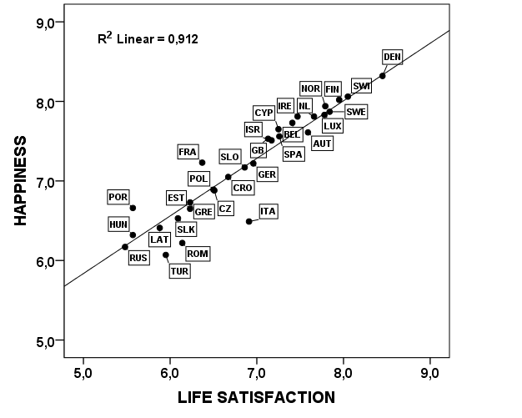

Figure 2. Happiness (combined happiness and life satisfaction) among natives and immigrants in Europe.
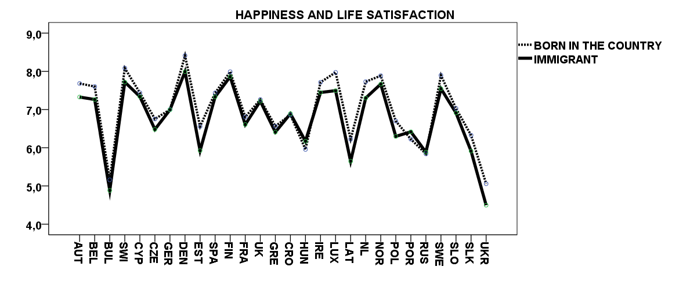

Figure 3. Happiness, gender, regime of birth and the regime of residence in Europe.
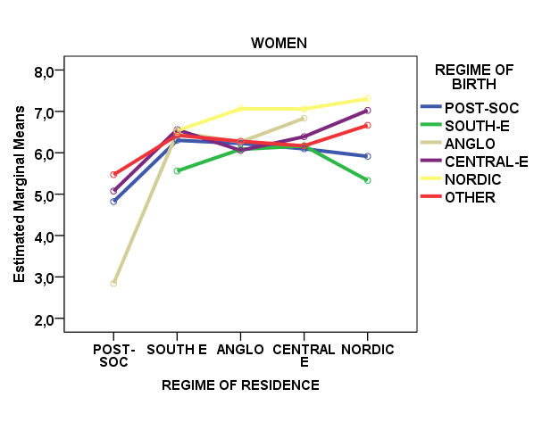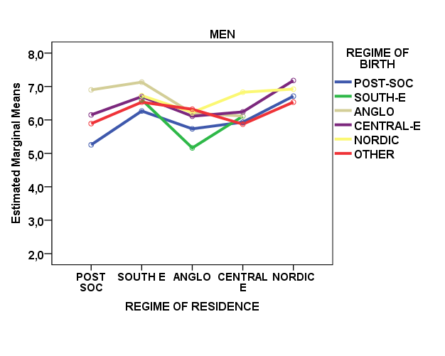

Figure 4. Interactions between happiness, bad health and regime of residence (upper left-hand panel) and regime of origin (upper right-hand panel) and interactions between levels of social capital (lower left-hand panel: trust in institutions; and lower right-hand panel: trust in people).

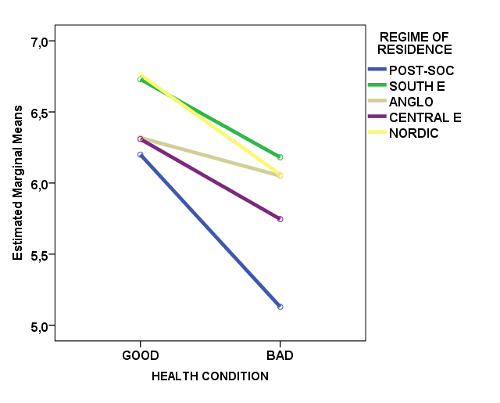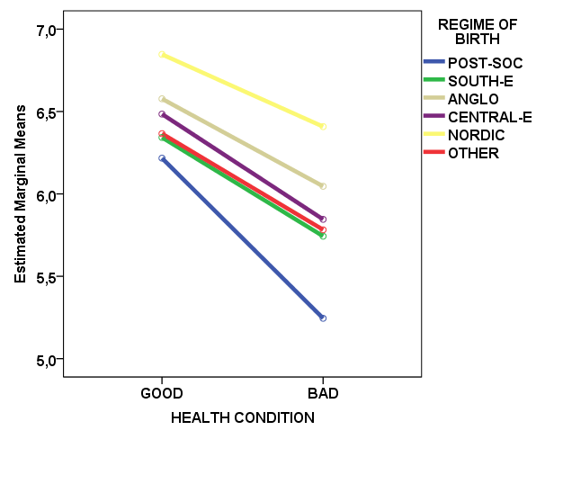

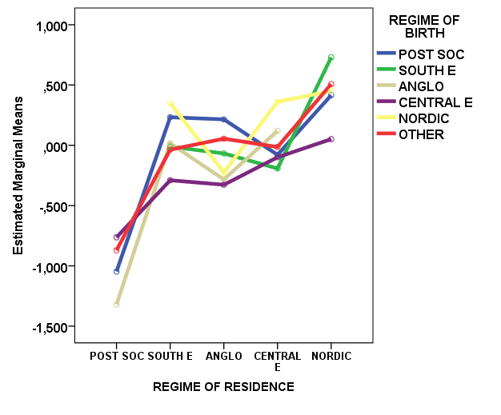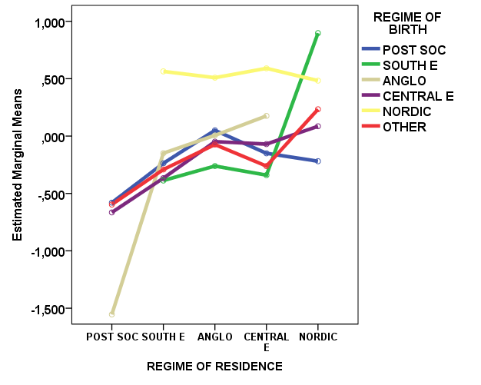

Figure 5. Unstandardised coefficients for country dummies (individual level characteristics controlled for) depicted against some country level characteristics.

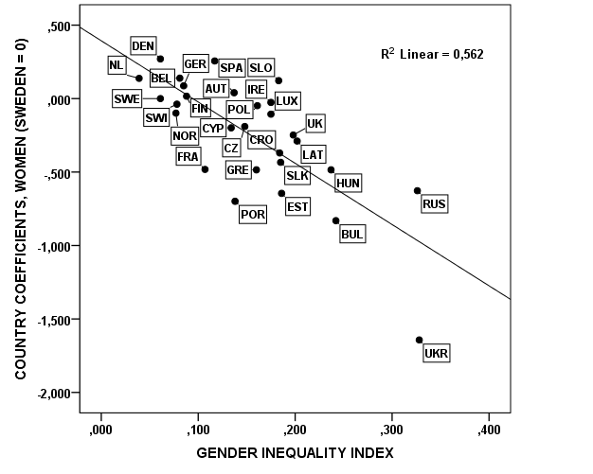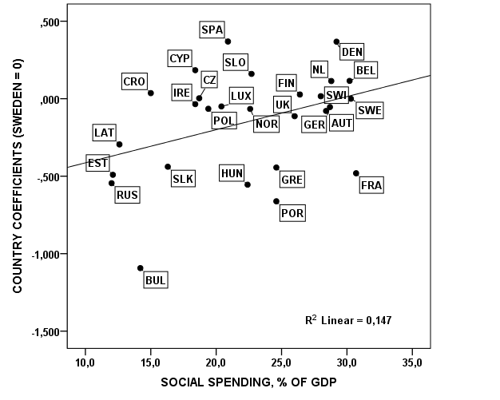

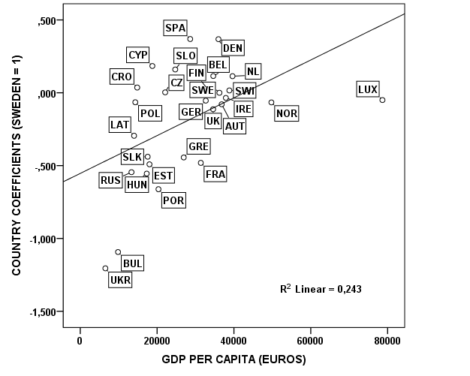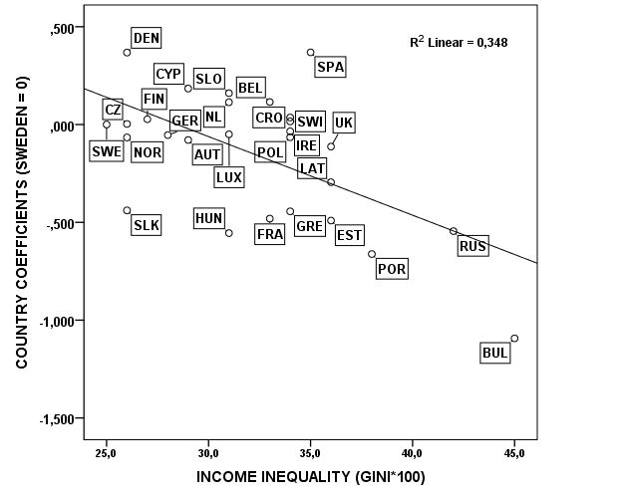

Table 1. Unstandardised OLS regression coefficients for happiness in different welfare state regime settings.
 | All countries | Post Socialist | South | Anglo | Central Europe | Nordic
Constant | 8,247*** | 7,827*** | 9,708*** | 8,105*** | 7,852*** | 8,604***
Gender | 0,096** | 0,155** | -0,196* | 0,070 | 0,234*** | 0,079
Age | -0,038*** | -0,032** | -0,068*** | -0,036** | -0,045 | -0,058**
Age squared/1000 | 0,402*** | 0,282 | 0,613*** | 0,494*** | 0,453*** | 0,658**
Economic difficulties | -1,001*** | -1,090*** | -0,842*** | -1,041*** | -0,977*** | -0,769***
Quartile | 0,050*** | 0,178*** | 0,018 | 0,009 | .139*** | 0,076
Bad health | -0,684*** | -0,612*** | -0,474*** | -0,534*** | -0,611*** | -0,666***
Unemployed | -0,402*** | -0,702*** | -0,288* | -0,640*** | -0,301*** | -0,504*
No friends | -0,533*** | -0,777*** | -0,851*** | -0,205 | -0,607*** | -0,789***
Feeling unsafe | -0,092** | -0,474*** | -0,058 | -0,229** | 0,088 | -0,241
Discrimination | -0,317*** | -0,345*** | -0,614*** | -0,291** | -0,248*** | -0,265
Trust in people | 0,306*** | 0,273*** | 0,221*** | 0,331*** | 0,270*** | 0,417***
Trust in institutions | 0,381*** | 0,370*** | 0,227*** | 0,355*** | 0,370*** | 0,248***
Regime of origin (non-European = reference)
Post-socialist | -0,196*** | -0,340*** | 0,006 | -0,279 | -0,029 | -0,094
Southern | 0,157* | 0,613 | 0,053 | -0,398* | 0,158 | -0,283
Anglo | 0,230*** | -0,263 | 0,787** | -0,91 | 0,352 | -0,081
Central Europe | 0,208*** | -0,084 | 0,288* | -0,280* | 0,277*** | 0,083
Nordic | 0,201** | 0,614 | 0,215 | 1,111 | 0,176 | 0,038
Adj. R squared | 0,305 | 0,302 | 0,222 | 0,258 | 0,247 | 0,228
Note: age squared was divided by 1 000 in order to make coefficient visible.

Appendix Table 1. Summary characteristics of immigrants in different welfare state regimes.
 | Welfare State Regime
 | Post-Socialist | South Europe | Anglo | Central Europe | Nordic
Happiness (mean / st.dev*.) | 5,50/2,28 | 7,06/1,82 | 7,22/1,77 | 6,98/1,96 | 7,68/1,76
Individual characteristics
Gender; share of women (%) | 58,8 | 50,6 | 52,5 | 53,4 | 54,0
Age (mean / st.dev.) | 51,8/18,1 | 38,3/14,1 | 44,2/17,4 | 43,8/16,6 | 46,3/17,4
Economic difficulties (%) | 64,6 | 38,9 | 21,7 | 26,9 | 16,0
Unemployed (%) | 4,5 | 13,3 | 5,5 | 8,8 | 6,8
Bad health (%) | 69,0 | 26,1 | 23,3 | 35,1 | 26,7
No intimate friend (%) | 15,3 | 10,1 | 9,8 | 9,9 | 10,0
Feeling unsafe (%) | 48,2 | 20,7 | 33,5 | 25,8 | 19,3
Discrimination (%) | 11,4 | 20,2 | 16,3 | 17,2 | 15,3
Trust in persons (mean / st.dev.) | -0,45/1,1 | -,23/0,9 | -0,14/0,9 | -0,03/0,9 | 0,48/0,9
Trust in national institutions (mean / st.dev.) | -0,88/1,0 | 0,01/0,9 | 0,11/0,9 | 0,97/0,9 | 0,42/0,9
Regime of origin (%)
Non-European (%) | 46,9 | 69,1 | 67,7 | 53,0 | 49,7
Post-socialist (%) | 49,1 | 12,8 | 7,5 | 20,9 | 12,6
South Europe (%) | 0,1 | 3,2 | 4,2 | 12,4 | 1,6
Anglo (%) | 0,1 | 2,6 | 10,3 | 1,7 | 2,7
Central Europe (%) | 3,8 | 11,7 | 9,4 | 11,5 | 8,3
Nordic (%) | 0,1 | 0,7 | 0,9 | 0,5 | 25,1
Country level data
Gini coefficient / st.dev. | 37,8/5,02 | 33,0/2,21 | 33,82/0,75 | 29,8/2,84 | 25,0/2,57
Poverty (%) / st.dev | 19,3/6,2 | 18,2/1,2 | 17,8/1,5 | 13,8/1,4 | 12,0/0,9
GDP per capita (2006) /st.dev. | 11750/4212 | 27259/2853 | 35118/667 | 33739/3758 | 38580/5590
Gender Inequality Index / st.dev. | 0,31/0,05 | 0,13/0,01 | 0,20/0,01 | 0,09/0,02 | 0,07/0,01
Social spending (% of GDP) / st.dev. | 15,0/4,2 | 22,9/2,1 | 22,9/3,7 | 27,7/3,1 | 27,4/3,2
Non-corrupt state index/st.dev. | 5,0/1,7 | 5,9/1,0 | 8,1/0,6 | 8,3/0,6 | 9,2/0,3
* standard deviation; Gender Inequality Index (GII) is a composite measure reflecting equality achievements between genders in three dimensions: health, empowerment and labour market. The higher the value the larger the gender disparity. World-wide the GII values vary from the low 0,05 in Sweden to 0,7 in Sierra Leone. The non-corrupt state index varies from 10 = very clean to 0 = highly corrupt. In 2006 the world-wide variation was from the high 9,6 in Finland to the low 1,6 in Chad.

Appendix Table 2. Within country and between country variance explained by individual explanatory variables; multilevel model including the country and the variable in question.
Variable | Variance explained within countries, % | Variance explained between countries, %
Gender | 0,0 | 0,1
Age | 3,5 | 0,3
Economic difficulties | 44,9 | 10,0
Income (quartile) | 10,4 | 5,1
Income (absolute) | 17,6 | 6,1
Bad health | 39,3 | 9,9
Unemployed | 0,1 | 1,8
No intimate friend | 6,8 | 2,6
Feeling unsafe | 13,5 | 1,4
Discrimination | 0,3 | 1,4
Trust in people | 30,1 | 7,8
Trust in national institutions | 43,9 | 9,3
Regime of origin | 11,0 | 0,6

The title of the paper is inspired by the most famous and melancholic Finnish tango written and composed by Unto Mononen in 1955. The lyrics of the tango tell about a desire to move overseas to a happy country of fairytales. Thus, the allusions in the title fit very well to my former position as an H. C. Andersen Professor in the happy country of Denmark. I became interested in the happiness of immigrants while working as H.C. Andersen Professor at the Centre of Welfare State Research, University of Southern Denmark. My Danish colleague Klaus Petersen once asked me whether a Finn becomes happier when moving to Denmark, the country that is often depicted to be the happiest country in the world. This study is a humble attempt to answer Klaus’s inquiry. I want to thank Wim van Oorschot and other participants of the ISA RC-19 annual meeting in Oslo for their valuable comments on the first draft of the article.
Esping-Andersen, Gosta (1990) Three Worlds of Welfare Capitalism. Cambridge: Polity Press.
For a more detailed discussion on welfare state models and their characteristics, see Castles, Francis, Leibfried, Stephan, Lewis, Jane, Obinger, Herbert & Pierson, Christopher (eds.) (2010) The Oxford Handbook of the Welfare State. Oxford: Oxford University Press.)
For overviews on the research field, see e.g. Leira, Arnlaug (2002) Working Parents and the Welfare State. Cambridge: Cambridge University Press Ferrarini, Tommy (2006) Families, States and Labour Markets. Institutions, Causes and Consequences of Family Policy in Post-War Welfare States. Cheltenham: Edward Elgar; Wilkinson Richard & Pickett Kate (2008) ‘Income Inequality and Socioeconomic Gradients in Mortality’. American Journal of Public Health 2008, Vol. 98, No 4, 699-704; Cooke, Lynn Prince (2011) Gender-Class Equality in Political Economies. New York & London: Routledge; Kvist, Jon, Fritzell, Johan, Hvinden, Björn & Kangas, Olli (eds.) (2012) Changing Social Equality: The Nordic welfare model in the 21st century. Bristol: Policy Press; Svallfors, Stefan (ed.) (2012) Contested Welfare States. Welfare Attitudes in Europe and Beyond. Stanford: Stanford University Press.
Layard, Richard (2006) Happiness. Lessons from a New Science. London: Penguin Books; Saari, Juho (2012) Onnellisuuspolitiikka (Politics of Happiness). Helsinki: Kalevi Sorsa Säätiö.Saari 2012; Marklund, Carl 2013.
The special issue: Clark, Andrew, Sauger, Nicholas & Senik, Claudia (2009) ‘Welfare, Well-Being and Immigration in Europe: Evidence from the European Social Survey’. Social Indicators Research, Vol. 91, No 3, 299-426; see also Eurostat (2011) Migrants in Europe: a statistical portrait of the first and second generation. Luxembourg: Eurostat; Senik, Claudia (2011) The French Unhappiness Puzzle: the Cultural Dimension of Happiness. Paris: Paris School of Economics, Working Paper No 12011 – 34.
Veenhoven, Ruut (1984) Conditions of Happiness. Dortrecht: Riedel. Veenhoven, Ruut (2002) ‘Why Social Policy Needs Subjective Indicators?’ Social Indicators Research, Vol. 58, Issue 1, 33-45; Layard, Richard (2006) Happiness. Lessons from a New Science. London: Penguin Books; Bok, Derek (2010) The Politics of Happiness – What Governments Can Learn from the New Research on Well-Being. Princeton: Princeton University Press; Saari(2012); Marklund in this volume).
Davidson Richard, D. (2004) ‘Wellbeing and Affective Style neural substrates and bio-behavioural correlates’. Philosophical Transactions of the Royal Society B: Biological Sciences, Vol. 359, 1395–1411.
Layard 2006, 11-21.
Marmot, Michael (1996) ‘The social pattern of health and disease’. In David Blane, Eric Brunner, Richard Wilkinson (eds.) Health and Social Organizations. London: Routledge, 42-67; Marmot, Michael (2002) ‘The Influence of Income on Health: Views of an Epidemiologist’. Health Affairs 2002; Vol. 21, No 1, 31-46; Kawachi Ichiro & Kennedy Bruce P. (2006) The Health of Nations: Why Inequality if Harmful to Your Health? New York: New Press, 2006; Wilkinson, Richard & Pickett, Kate (2009) Spirit Level. Why Greater Equality Makes Societies Stronger? New York, Berlin, London: Bloomsbury Press; Bachans, Mona (2011) Gender Policy and Gender Equality in Public Health Perspective. Stockholm: Karolinska Institutet.
Hayek, Friedrich (1960) The Constitution of Liberty; London: Routledge; Nozick, Robert (1979) Anarchy, State and Utopia. Oxford: Blackwell.
Wilkinson, Richard & Pickett, Kate (2009) Spirit Level. Why Greater Equality Makes Societies Stronger? New York, Berlin, London: Bloomsbury Press.
Allardt, Erik (1975) Att ha, att Älska, att Vara. Om välfärd i Norden. Lund: Argos; Allardt, Erik (1993) ‘Having, loving and being: An alternative to the Swedish model of welfare research’, in Nussbaum, Martha & Sen, Amartya (eds.) The Quality of Life. Oxford: Clarendon Press, 88-94; Ringen, Stein (1987) The possibility of politics. Oxford: The Clarendon Press; Erikson, Robert & Uusitalo, Hannu 1987) ‘The Scandinavian approach to welfare research’, In Erikson, Robert, Hansen Erik-Jørgen, Ringen, Stein & Uusitalo, Hannu (eds.), The Scandinavian Model. Welfare state and welfare research. Armonk, New York & London: M.E. Sharpe, 177-193.
Morel, Nathalie, Palme, Joakim & Palier, Bruno (eds.) (2011) Towards Social Investment Welfare State. Bristol: Policy Press.
Johansson, Sten (1970) Om levnadsnivåundersökningen. Stockholm: Allmänna förlaget. Johansson, Sten (1979) Mot en teori om social rapportering. Stockholm: Institutet för social forskning.
Allardt (1975); Allardt (1993).
Sen, Amartya (1992) Inequality re-examined. Oxford: Oxford University Press; Sen, Amartya (1993) “Capability and well being’, In Nussbaum, Martha & Sen, Amartya (eds.) The Quality of Life. Oxford: Clarendon Press, pp. 30-53; Sen, Amartya (2010) The Idea of Justice. London: Penguin Books.
Aristotle (1955) Ethics. London: Penguin Books.
For a mental map of different approaches, see Saari 2012, 19.
Danner, Deborah, Snowdon, David & Friesen, Wallace (2001) ‘Positive emotions in early life and longevity: Findings from the nun study’. Journal of Personality and Social Psychology, Vol. 80, No 5, 804-813.
Davidson, Richard, D. (2000) ‘Affective style, psychopathology, and resilience: Brain mechanisms and plasticity’. American Psychologist, Vol. 55, No 11, 1196-1214; Davidson Richard, D. (2004) ‘Wellbeing and Affective Style neural substrates and bio-behavioural correlates’. Philosophical Transactions of the Royal Society B: Biological Sciences, Vol. 359, 1395–1411.
For a detailed discussion on the issue, see e.g., Hyyppä, Markku T. & Mäki, Juhani (2001) ‘Individual-Level Relationships between Social Capital and Self-Rated Health in a Bilingual Community’. Preventive Medicine Volume 32, Issue 2, February 2001, Pages 148–155; Kawachi, Ichiro, Subramanian, S. V. & Kim, Daniel (2008) Social Capital and Health. New York: Springer.
Putnam, Robert (1993): Making Democracy Work. Princeton: Princeton University Press; Putnam, Robert (2000): Bowling alone: The collapse and revival of American community. New York: Simon & Schuster; Whiteley, Paul (2000) ‘Economic growth and social capital’. Political Studies, Vol. 48, pp. 443-466.
Rothstein, Bo (1998) Just Institutions Matter. The moral and Political Logic of the Universal Welfare State. Cambridge: Cambridge University Press; Rothstein, Bo (2003) Sociala fällor och tillitens problem. Stockholm: SNS.
Allardt (1975) and (1993).
Rothstein (1998).
http://www.archive.transparency.org.
Scheepers, Peer, Grotenhuis, Te & Gelissen, John (2002) ‘Welfare states and dimensions of social capital’. European Societies, Vol. 4, No 2, 185-207; Fridberg, Torben & Kangas, Olli (2008) ’Social Capital’. In Ervasti, Heikki, Fridberg, Torben, Hjerm, Mikael & Ringdal, Krister (eds.) Nordic Social Attitudes In A European Perspective. Cheltenham: Edward Elgar, 65-85.
Wilkinson Richard & Pickett Kate (2006) ‘Income inequality and population health: A review and explanation of the evidence’. Social Science and Medicine, Vol. 62: No 7, 1768-1784; Wilkinson Richard & Pickett Kate (2008) ‘Income Inequality and Socioeconomic Gradients in Mortality’. American Journal of Public Health 2008, Vol. 98, No 4, 699-704; Wilkinson & Pickett (2009); Kawachi Ichiro & Kennedy Bruce P. (2006) The Health of Nations: Why Inequality if Harmful to Your Health? New York: New Press, 2006.
Jahoda, Marie, Lazarsfeld, Paul, E. & Zeisel, Hans (2002) [1933] Marienthal. The Sociography of an Unemployed Community. New Brunswick: Transaction Publishers.
Nelson, Kenneth (2003) Fighting Poverty: Comparative Studies on Social Insurance, Means-tested Benefits and Income Redistribution. Stockholm: Dissertation Series No. 60. Swedish Institute for Social Research.
Korpi, Walter (2000) ‘Faces of Inequality: Gender, Class and Patterns of Inequality in Different Types of Welfare States’. Social Politics, Vol 7, No 2, 127-191; Korpi, Walter, Ferrarini, Tommy & Englund, Stefan (2012) Women’s opportunities under Different Family Policy Constellations: Gender, Glass and Inequality Tradeoffs in Western Countries Re-exmined. Social Politics (forthcoming); Leira, Arnlaug (2002) Working Parents and the Welfare State. Cambridge: Cambridge University Press; Meager, Gabriella & Szebehely, Marta (2012) ‘Equality in the social service state: Nordic child care models in comparative perspective’. In Kvist, Jon, Fritzell, Johan, Hvinden, Björn & Kangas Olli (eds.). Changing social equality: The Nordic welfare model in the 21st century. Bristol: Policy Press, pp. 89-117.
Mandel, Hadas, Semyenov, Moshe (2006) ‘A Welfare State Paradox: State Interventions and Women’s Employment Opportunities in 22 Countries’. American Journal of Sociology, Vol. 111, No 6, 1910-1949. Mandel, Hadas, Shalev, Michael (2009) ‘How Welfare States Shape the Gender Pay Gap: A Theoretical and Comparative Analysis’. Social Forces, Vol. 87, No 4, 1873-1912; Datta-Gupta, Nabanita, Smith, Nina & Verner, Mette (2008) ’The Impact of Nordic Countries’ Family Friendly Policies, Employment, Wages, and Children’. Review of the Economics of the Household, Vol. 6, No 1, 65-89.
For a closer description, see http://www.europeansocialsurvey.org.
Iceland (a country that displays a very high level of happiness) was left out of the analysis because of the insufficient number of immigrant respondents.
For clustering countries, see Castles & al. (2010); Design weight is used in regression models when operating with countries, while data are weighted by population weight when analysing data regime-wise.
Indicators are for the year 2006 which is in the middle of our observation period. A better strategy would have been to take an average for the entire observation period. However, all the indicators used here are rather sticky and changes in them are slow. Therefore, the choice to use the 2006 values instead of averages for 2002 – 2010 does not affect the results. Data are taken from UN Human Development Index (http://www. hdr.undp.org).
Senik (2011).
Rothstein (1998)

