Strengthening of sustainability expertise

According to the new strategic plan of the University of Helsinki for 2021–2030, the theme of sustainability is to run through all of the University’s educational offerings. This means making sustainability expertise part of discipline-specific knowledge and skills as well as generic expert skills. You can use the competency maps on the following pages to identify sustainability expertise in curriculum design. You can also answer the questions together in a workshop, for example, by sharing a link to the Word document (e.g. in Teams) or using Flinga. Tips for using Flinga can be found at the end of this document.

Name of the degree programme:

Describe, what kind of sustainability expertise the degree programme provides and enables:
Which knowledge, skills, values and attitudes are key to discipline-specific sustainability expertise?

- ….

competency maps for identifying sustainability expertise

You can use the competency maps below in curriculum design to identify sustainability competencies. Examples of identifying sustainability competencies can also be found in Flamma's Instructions and guidelines:

- Examples of the operationalisation of sustainability skills (PDF)
- Supporting the development of generic academic skills during bachelor’s studies (PDF) ​​​​​​
- Supporting the development of generic academic skills during master’s studies (PDF)

Discipline-specific knowledge and skills related to sustainability

Sustainability expertise provided and enabled by the degree programme | Description of learning objectives | Teaching and guidance methods  (incl. student activities / actions and forms of teacher cooperation) | Assessment of competence (How is competence and the accumulation of competence assessed?) | In which study unit / course is this competence produced?
Key theories and concepts related to sustainability

Key research methods related to sustainability |  | E.g. research methods courses, assignments that include data collection and analysis, collaboration with research staff, what other activities develop this competence?
Applicability of the knowledge in practice in relation to sustainability |  | E.g. projects, project courses, thesis, work practice, what other activities develop this competence?
What else?

Generic academic skills (incl. sustainability skills) that are integrated into discipline-specific studies

Generic academic skills | Description of learning objectives | Teaching and guidance methods  (incl. student activities / actions and forms of teacher cooperation) | Assessment of competence (How is competence and the accumulation of competence assessed?) | In which study unit / course is this competence produced?
Identification and management of personal expertise |  | E.g. PSP, self study, preparation for contact teaching and for guidance meetings, systematic evaluation of one's own activities, projects, project work, thesis, work practice | E.g. continuous evaluation and feedback as the work progresses, peer review, feedback from stakeholders and different disciplines.
Communication, interaction and collaboration skills |  | E.g. Collaborative learning, problem-based learning, project-based learning, interdisciplinary group instruction, group discussion (e.g., supervising a dialogue based on the Timeout  method)
Scholarly and ethical thinking |  | E.g. Article seminars, interactive discussions, debates, panel discussions, use of different kinds of data sets and references, scientific writing, systematic argumentation teaching and systematic and varied feedback
Systemic thinking |  | E.g. Case-based teaching (case studies), mind and concept maps, project-based  learning, problem-based learning, life cycle analysis, analysis of supply or  value chains, projects with local operators, field instruction, place-  based learning
Futures thinking |  | E.g. Case-based teaching (case studies), project-based learning, problem-based learning, participatory action research, life cycle analysis, analysis of supply or value chains, practical projects with local communities
Strategic thinking and agency |  | E.g. Challenge-based learning, project-based learning, problem-based learning, collaborative learning, interdisciplinary group instruction, participatory action research

Describe, what kind of sustainability expertise the degree programme provides and enables:

Which Sustainable Development Goals of the UN are key to the degree programme, or how the objectives of the degree support the sustainability transition, or how the objectives of the degree support the description of sustainability as used in the discipline?

- …

Sustainability has been defined in different ways. If you wish, you can use the definitions and frameworks on the following pages to help you. Examples have been taken from the University of Helsinki Sustainability Course (SUST-001), and they can be found in the preview version of the course:
University of Helsinki (2021). Sustainability Course [MOOC]. Retrieved June 17, 2021 from https://mooc.helsinki.fi/course/view.php?id=494 It is also possible to log in the course area as a guest and no registration is needed (click “Log in as a guest”/ “Kirjaudu vierailijana”).

What does sustainability mean?  Sustainability is the ability to exist constantly. Nowadays, sustainability refers generally to the co-existence of human race and the rest of nature on the Planet, and a process in which people’s actions are in harmony with the rest of the nature and enhance both current and future potential to meet human needs and aspirations, as well as the needs of non-human species and ecosystems. Sustainable development, in turn, refers to the development towards this state.  What does sustainability look like?  Sustainability is often defined through the following interconnected domains or pillars: environment, economic and social, although for example cultural domain is often also included. Environmental or ecological sustainability refers to healthy, functioning ecosystems; social sustainability is equal opportunity to fulfil basic human needs; and economic sustainability to fair allocation and distribution of scarce resources (UN 2012). It is also increasingly acknowledged that instead of being parallel, these domains are nested and economic and social sustainability are dependent on environmental sustainability. This is called a “strong sustainability” approach that highlights the dependence of any human action on well-functioning ecosystems. The strong sustainability approach also highlights the idea that the economy is an instrument rather than a goal: functioning ecosystems (ecological sustainability) and human rights and equality (socio-cultural sustainability) are considered by many to be goals and values, while economic sustainability is a tool to achieve these intrinsic goals. | 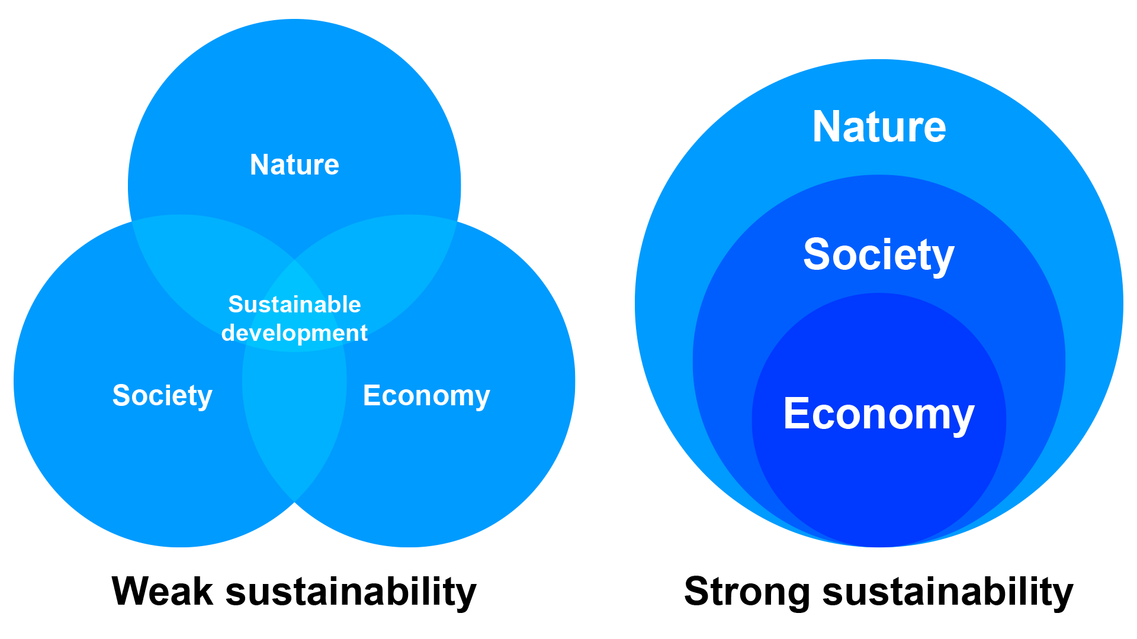  Figure 1. Graphic presentation of weak and strong sustainability. Weak sustainability (left) or sustainable development present the environmental, social, and economic themes with equal weighting and seeks to balance them. Strong sustainability (right), with focus on systems, presents the three themes as nested and confers different sizes and weighting to them. Redrawn from Morandín-Ahuerma et al. 2019.  Original reference / Additional reading:  Laakso, S. & R. Sinquefield-Kangas (2021). Brief background of the concept. In University of Helsinki (2021). Sustainability Course [MOOC], Module 1, Book 1, Chapter 1. Retrieved June 17, 2021 from https://mooc.helsinki.fi/course/view.php?id=494

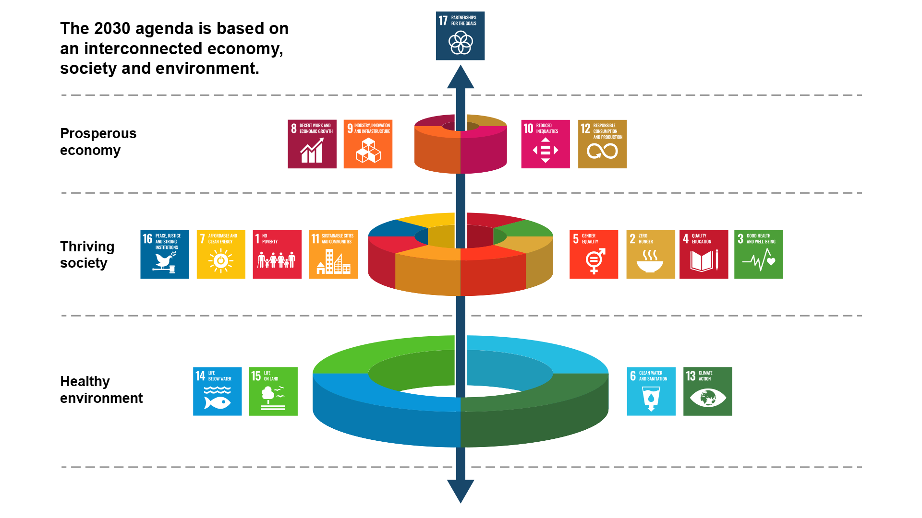
Figure 2. Seventeen Sustainable Development Goals (SDSs) of the United Nations. Nature (i.e., the biosphere) is the foundation upon which global sustainability is built. Redrawn from Rockstrom and Sukhdev 2016, (Azote Images for Stockholm Resilience Centre).

The Sustainable Development Goals  The Sustainable Development Goals (SDGs), also known as the Global Goals, were adopted by all United Nations Member States in 2015 as a universal call to action to end poverty, protect the planet and ensure that all people enjoy peace and prosperity by 2030. The 17 SDGs are integrated —that is, they recognize that action in one area will affect outcomes in others, and that development must balance social, economic and environmental sustainability.  The goals reflect the global consensus on improving sustainability. They have important implications for policy and research, in areas ranging from climate protection to gender issues. The SDGs are complex and interwoven; the success of one goal is often closely linked to that of another. Timely and impactful implementation of the goals therefore requires interdisciplinary research. | 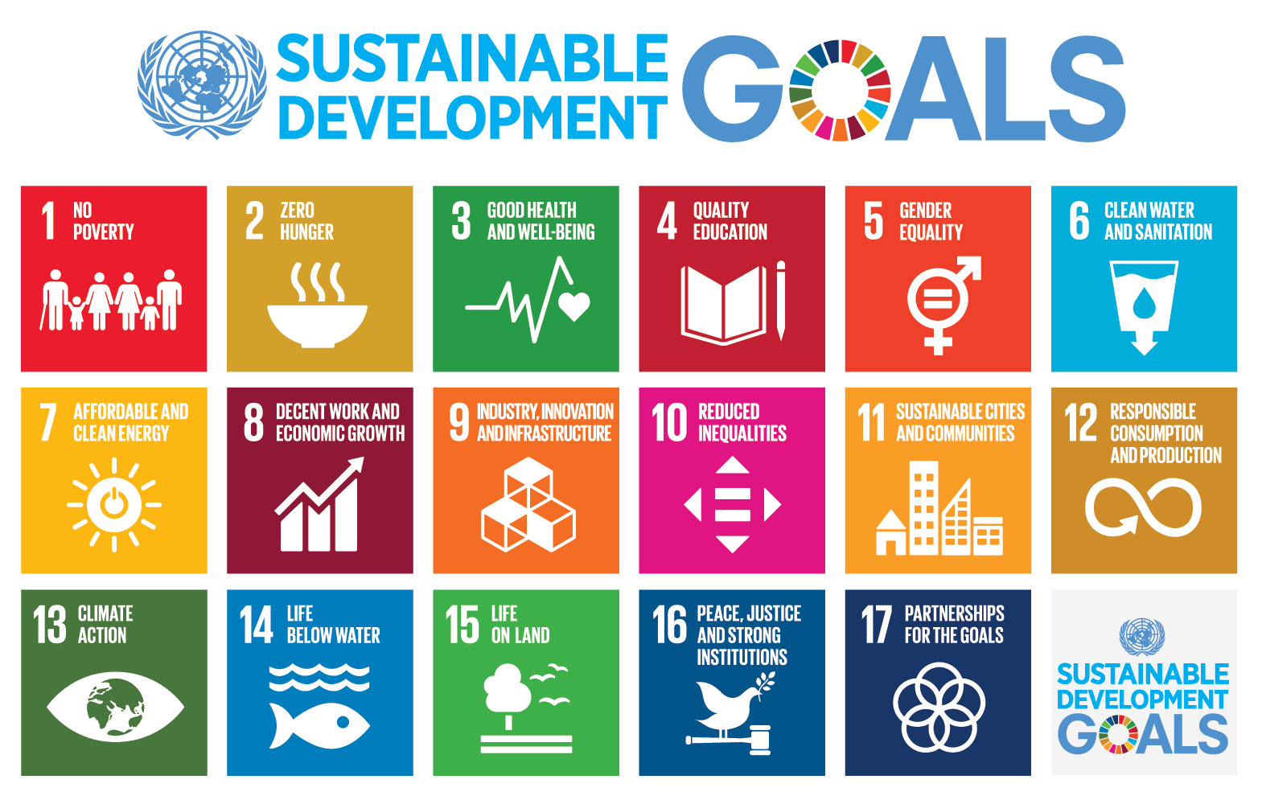  Figure 3. Seventeen Sustainable Development Goals (SDSs) of the United Nations. (Public Domain)  Original reference / Additional reading:  Dobrego, A., Kruskopf, M. & H. Lammassaari (2021). My Expertise. In University of Helsinki (2021). Sustainability Course [MOOC], Module 2, Book 1, Chapter 2. Retrieved June 17, 2021 from https://mooc.helsinki.fi/course/view.php?id=494

Challenging sustainability – Critical approach  Global goals are not universal – they should be interpreted locally.  Even though the United Nations Agenda 2030 is designed as universal goals for sustainability, their universality must be questioned in many instances. It is generally recognized that human rights are essential to achieve sustainable development, because if we are not enjoying human rights on an equal base across the globe without any difference of who we are, there is not much we can do in order to enhance a universal and thus global solution to sustain the world. At the same time human rights goals and those of sustainable development are oftentimes in conflict.  The document Transforming our world: The 2030 Agenda for sustainable development, adopted by the United Nations General Assembly on October 21st 2015 (A/RES/70/1) puts its main thrust in that all the policies and processes targeting the implementation of the Sustainable Development Goals (SDG) should be based on human rights. Agenda 2030 reaffirms several significant human rights commitments. In the section on ‘Our shared principles and commitments’, the paragraph 10 states:  ”The new Agenda is guided by the purposes and principles of the Charter of the United Nations, including full respect for international law. It is grounded in the Universal Declaration of Human Rights, international human rights treaties, | the Millennium Declaration and the 2005 World Summit Outcome. It is informed by other instruments such as the Declaration on the Right to Development (ibid. 4).”  Thus, the Agenda is explicitly based on international human rights standards and affirms realizing human rights for all as its goal. But human rights and development do not always go hand in hand (Woods 2010). This is more particularly the case in relation to the rights of Indigenous peoples but also many other minorities.  Some scholars blame Agenda 2030 for not challenging the positions of powerful actors such as big countries, international financial institutions, transnational corporations and international NGOs that have produced and reproduced inequalities in income, wealth and power at national and global levels, causing the very problems the Sustainable Development Goals are trying to solve (Esquivel & Sweetman 2016; Struckmann 2018, 19, Toivanen & Kmak 2021). Local peoples’ agency does not receive enough recognition in current thinking about sustainability, particularly those in the Global South (Struckmann 2018).  Original references / Additional reading:  Toivanen, R. & C. Casi (2021). Critical approach. In University of Helsinki (2021). Sustainability Course [MOOC], Module 1, Book 2, Chapter 3. Retrieved June 17, 2021 from https://mooc.helsinki.fi/course/view.php?id=494

The six ‘entry points’ identified by the United Nations  In this chapter you can find a brief introduction to the six entry points of transformation. These entry points, identified by the United Nations (UN), provide a systematic guide for key institutions in which transformation towards a more sustainable society can take place. The UN views these six themes as ‘entry points’ that serve to interlink and accelerate the changes needed to achieve the UN Agenda 2030 Sustainable Development Goals.  - Human well-being and capabilities  - Sustainable and just economies  - Food systems and nutrition patterns  - Energy decarbonisation and universal access  - Urban and peri-urban planning  - Global environmental commons | 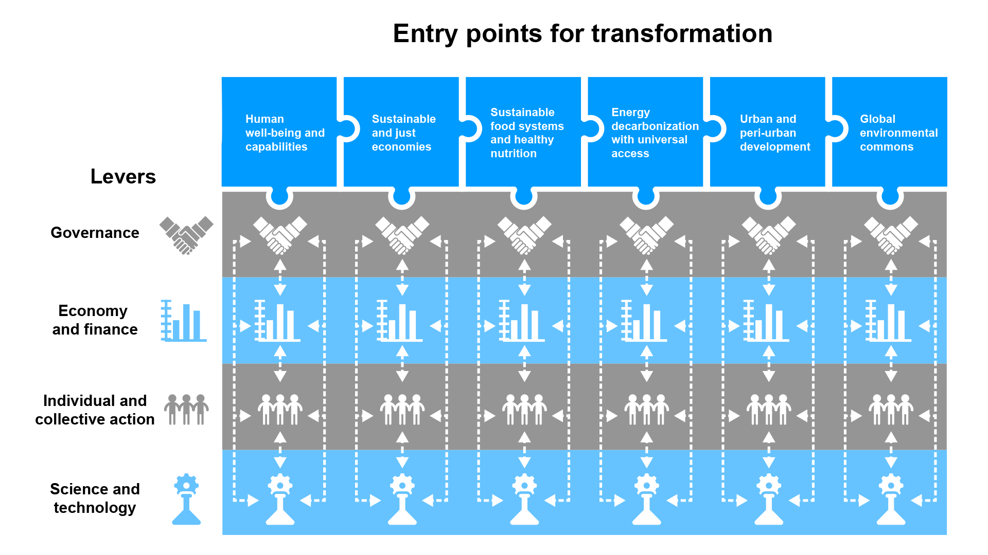  Figure 4. Entry points of transformation towards a more sustainable society, identified by the United Nations, Independent Group of Scientists appointed by the Secretary-General (2019). Global Sustainable Development Report 2019: The Future is Now – Science for Achieving Sustainable Development, United Nations, New York. https://sustainabledevelopment.un.org/gsdr2019

Institutional tools of change and collective agency

The United Nations (2019) argues that in addition to the six entry points, there are four levers that can be used to balance the necessary steps that need to be taken to achieve human well-being without letting the environmental and social costs become too high. The levers are: governance; economy and finance; science and technology; and individual and collective action. In order to effectively drive sustainability forward, the UN views that a diverse set of actors needs to be included in the process. This would include collaboration between more traditional stakeholders, such as governments, and emerging actors.

According to the UN, all of these levers have to work together, seamlessly, within a particular sustainability entry point in order to drive change (see examples in table below). However, in order to create knock-on effects across the entry points, it also needs to be recognized that each entry point is fundamentally connected to all other entry points, as well.

Original references / Additional reading:

Ruippo, L. (2021). The six ‘entry points’ identified by the UN. In University of Helsinki (2021). Sustainability Course [MOOC], Module 1, Book 1, Chapter 2. Retrieved June 17, 2021 from https://mooc.helsinki.fi/course/view.php?id=494

Kruskopf, M., Numminen, E., Ratvio, R. & O. Ollinaho (2021). Institutional Tools of Change. In University of Helsinki (2021). Sustainability Course [MOOC], Module 2, Book 2, Chapter 2. Retrieved June 17, 2021 from https://mooc.helsinki.fi/course/view.php?id=494

tips for using flinga

- Competency maps can also be answered collectively in the edu.flinga.fi service. You should first save the tables as image files on your own computer, by taking a screenshot from the Word file or downloading image files directly from the Sustainability Expertise Workshop materials on the Educating Sustainability Experts -blog. https://blogs.helsinki.fi/uhsustained/2022/02/07/sustainability-expertise-in-curriculum-design-workshop-materials-4-2-2022/
- The image file can be 1) uploaded to Flinga using the camera button. After that 2) set the image type to Background and stretch the image to a suitable size. You should also lock the image in place with the lock button. Now you can place post-it notes on Flinga, for example.
